# R&S PA Compression Test

# Initial Version

# For: Freescale, Barry Adkins

**User Settings:**

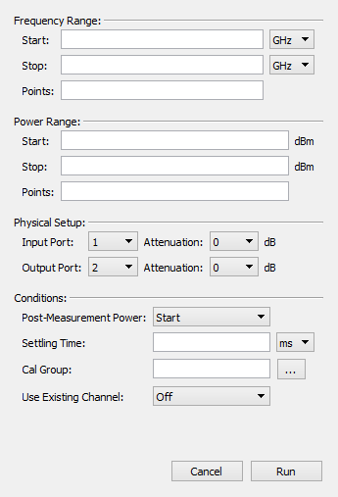

Note: Are there any other settings that users may require (such as accommodations for User Defined Ports setups)?

**Proposed measurement profile:**

Segmented frequency sweeps are performed for each power level. The initial sweep is at the lowest power level (P1) for all frequencies (F1…FN). After a sweep, calculations on current data set are performed to determine which frequencies have reached compression. Frequencies that have reached compression point are removed from the next sweep.

The table below gives an example of this measurement scheme.

|  |  | Sweeps | | | | | | | |
| --- | --- | --- | --- | --- | --- | --- | --- | --- | --- |
|  | P1 | P1 | P2 | … | PN-4 | PN-3 | PN-2 | PN-1 | PN |
|  | F1 | ■ | ■ |  | ■ | ■ | ■ | ■ |  |
| F2 | ■ | ■ |  | ■ |  |  |  |  |
| … | ■ | ■ |  |  |  |  |  |  |
| FN-2 | ■ | ■ |  | ■ | ■ | ■ |  |  |
| FN-1 | ■ | ■ |  | ■ | ■ |  |  |  |
| FN | ■ | ■ |  | ■ |  |  |  |  |

*■ Frequency point measured*

The horizontal header (left) lists all the desired frequency points. The vertical header (top) lists each sweep by power level. For each sweep, a ‘■’ indicates that the corresponding frequency point will be included in the segmented sweep. Sweeps continue until either the maximum power is reached or all frequency points have gone into compression, whichever comes first.

In the example above, the last sweep would be PN-1, since the last frequency point F1 goes into compression at PN-1 (hence no frequencies are left for sweep PN).

**Gain Expansion:**

As Barry/Freescale have requested, gain expansion will be taken into account: the compression point will be calculated from the maximum gain. For amplifiers with gain expansion, this will not be at the lowest power level.

# Second Version: Advanced features

**Remote control**

The initial version of the application will be controlled from the GUI without any external control. Once we get a version to the customer and get some feedback, we can begin to create a version that can be externally controlled. This will mostly likely be through a SCPI-like command interface, or by importing a C\C++ library into the customer’s project. We can discuss this with the customer.

**Pulsed RF**

Additional settings or external control points may be necessary to measure pulsed RF devices. This feature will also be discussed with the customer.